Find the measurements requested for the waveform shown below.
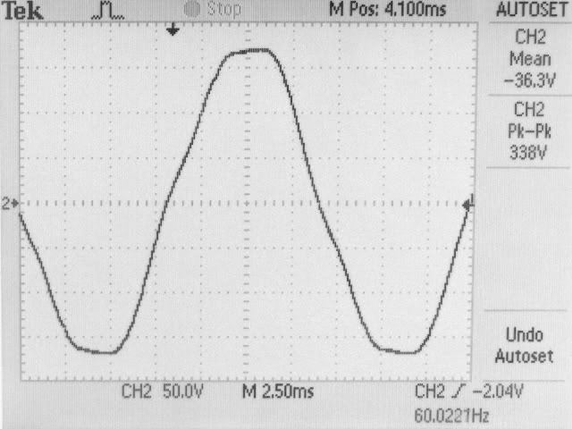
- Find the period of this repetitive waveform.
T = ________ ___
- Find the frequency of this repetitive waveform.
f = ________ ___
- Find the pulse amplitude for the waveform.
PA = ________ ___
- On the graph above show how to measure the pulse width of the waveform and record the value here.
PW = ________ ___
- On the graph above show how to measure the rise time tr and the fall time tf of the waveform, and record the values here.
tr = ________ ___
tf = ________ ___
- Find the duty cycle for the waveform.
duty cycle = ________
- Which waveforms contain harmonic frequencies?
  - only sine waves
  - only square waves
  - all waveforms including sine waves
  - all waveforms except sine waves
____
- Poorly adjusted RF amplifiers often produce second harmonics which may then be broadcast. If a trucker uses a poorly adjusted CB radio on 27 MHz, what will the frequency of the second harmonic be?
f(2nd) = ________
- The specifications for an amplifier indicate that the power gain of an amplifier is 150,000. What is the decibel power gain of the amplifier?
Ap (dB) = ________
- The input voltage to an amplifier is 10 millivolt and the output voltage is 1.2 Volts. What is the decibel voltage gain of the amplifier?
Av (dB) = ________
- Assume a certain amount of power is attenuated by - 10dB. If the input power to the attenuator is 1 watt, what is the output power?
POUT = __________
- Calculate the upper cutoff frequency f₂ of the circuit below.
f2 = __________
- If the input voltage to the circuit above is 100 volts and the frequency of the input is equal to the upper cutoff frequency f2 what is the output voltage?
V_{O} __________

- A differential circuit amplifies
  - only AC.
  - only DC.
  - both AC and DC.
  - neither AC nor DC.
_____
- The voltage difference between the inputs of a differential amplifier needed to give a zero output voltage is called the
  - input offset current
  - input bias current
  - output impedance
  - input offset voltage
_____
- A differential amplifier has a gain of 100 when a difference signal is applied, and a gain of 0.2 when a common-mode signal is applied to both inputs. Calculate the CMRR as a ratio and in dB. Show your calculations.
CMRR = __________
CMRR (dB) = __________
_____
- When an op amp is operated without feedback is it said to be operating
  - derated.
  - compensated
  - open-loop.
  - closed-loop.
_____
- The waveform shown below is the output of an op-amp with a (perfect) pulse input. What is the slew rate of the amplifier?
slew rate = __________ volts/μs
- When any waveform exceeds the slew rate of the op amp,
  - the op amp works best.
  - the voltage gain is maximum.
  - linear operation occurs.
  - distortion occurs.
_____
- Assume a saturation voltage of ±14 volts for a 741 op amp. If the open loop gain for the op amp is 200,000, what differential input voltage V_{IN} = (V_{IN+} - V_{IN-}) will be required to cause the output to just saturate?
V_{IN} = __________
- Adding negative feedback to an amplifier
  - increases the input and output impedances.
  - increases the input impedance and decreases the output impedance.
  - decreases the input impedance and increases the output impedance.
  - decreases the input and output impedances.
_____
- The use of negative feedback
  - reduces the voltage gain of an amplifier from its open-loop value.
  - increases the voltage gain of an amplifier from its open-loop value.
  - has no effect on the voltage gain of the amplifier.
  - can either increase or decrease the voltage gain of the amplifier from its open-loop value.
_____
- A non-inverting amplifier circuit has a closed-loop gain of 25. The op-amp by itself has an open-loop gain of 100,000. If a new op-amp with an open-loop gain of 200,000 is substituted in the circuit, the circuit closed-loop gain will
  - decrease by a factor of 2.
  - increase by a factor of 25.
  - increase by a factor of 2.
  - change very little.
_____
- Draw the circuit for an inverting amplifier. Give each resistor a label, and label the input and output connections.
-
+

- Write the formula for the voltage gain of the inverting amplifier in terms of the resistor labels you used in the previous question.

- Draw the circuit for a non-inverting amplifier. Give each resistor a label, and label the input and output connections.

-
+

- Choose resistors for the non-inverting amplifier circuit above so that an AC input voltage of 150 millivolts peak-to-peak will produce an output voltage of 1.0 volt p-p. Mark the resistor values on the drawing above. Show your calculations below.

- Compensation prevents an amplifier from oscillating. What is the disadvantage of fully compensating an amplifier?
  - reduced bandwidth
  - increased oscillation amplitude
  - reduced phase margin
  - reduced positional notation
_____
- The boxes shown below contain amplifiers. The input and output waveform of each is shown. Which of the amplifiers is a linear amplifier ?

_____
- How many output voltage levels can a 14-bit D/A converter produce?
__________ levels

- An input transducer converts
  - voltage to current.
  - current to voltage.
  - a non-electrical quantity to an electrical quantity.
  - an electrical quantity to a non-electrical quantity.
_____
- In electronic circuits the term rail refers to _____________________________________.

- In electronic circuits the term rail to rail refers to _____________________________________.

- Define Transducer:

- The TI SN754410 Quadruple HALF H DRIVER is a:
_____
  - Logic
  - Linear
  - Mixed Signal
  - Transmitter

- An LM35 is a:
_____
  - Logic
  - Linear
  - Mixed Signal
  - Transmitter
- A junction between two different metals that produces a voltage related to a temperature difference.

  - Thermal Coupler
  - Thermal Coupling
  - RTD
  - Thermocouple
_____

A system which uses 4-20mA might be called a: _____________
  - Current Loop
  - Eddy Current
  - Transducer
  - Transmitter
- Calculate the output voltage from the binary-weighted summing amplifier shown below.
V_{O} = __________
- List the five basic types of filter responses:

- Attenuation refers to:
  - a loss of signal strength.
  - a constant signal.
  - a gain of signal strength.
  - Phase shift in the signal.
_____
- The order of a filter is
  - the number of inductors and capacitors in the filter.
  - the number of resistors in the filter.
  - the number of operational amplifiers or transistors in the filter.
  - the number of ripples in the passband or stopband.
_____
- The world's loudest band, is:
  - Metallica
  - Spin̈al Tap
  - Cradle of Filth
  - Herb Alpert & the Tijuana Brass
_____
- A filter is designed to filter out 60 Hz from a guitar amplifier, but to allow other frequencies above and below 60 Hz to be amplified. This would be a
  - low-pass filter.
  - band-pass filter.
  - high-pass filter.
  - band-stop filter.
_____
- The filter shown below is a
  - first-order high-pass filter.
  - first-order low-pass filter.
  - second-order high-pass filter.
  - second-order low-pass filter.
  - Mrs. Butterworth's
_____
- A comparator typically has
  - an analog input voltage and an analog output voltage.
  - an analog input voltage and a digital output voltage.
  - a digital input voltage and a digital output voltage.
  - a digital input voltage and an analog output voltage.
_____
- A Schmitt trigger is a comparator with ___________________ and ____________________.

- Using the following schematic and output plots, label each plot with its node name (A,B,C, and D).
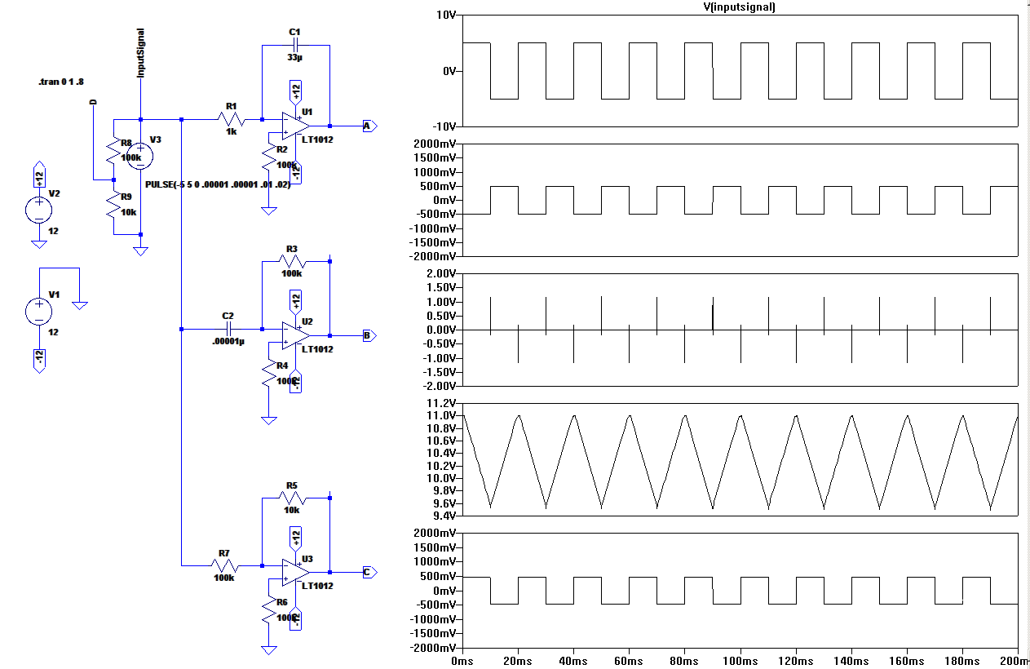
- Using the above schematic and output plots, indicate what type of circuit you see (the common name) for the nodes A,B,C, and D.

A. ________________________________________

B. ________________________________________

C. ________________________________________

D. ________________________________________
- An oscillator differs from an amplifier because
  - it requires no dc supply voltage to make an output signal.
  - it always has a higher gain.
  - it requires no input signal to make an output signal.
  - it has an inverted output signal.
_____
- One condition for oscillation in any feedback oscillator is that the amplifier and the feedback network together have a phase shift of
  - 180°.
  - one-fifth (1/5).
  - five.
  - 0° (or 360°)
_____
- Another condition for oscillation in any feedback oscillator is that the total gain of the amplifier and the feedback loop must be at least
  - zero.
  - one-fifth.
  - one.
  - three.
_____
- An astable multivibrator
  - provides a time-delay dependent on the input pulse width.
  - oscillates when supplied with only DC power.
  - puts out a fixed-width pulse each time it is triggered.
  - rejects all frequencies except one frequency.
_____
- A monostable multivibrator is also called a
  - flip-flop.
  - oscillator.
  - single-frequency filter.
  - one-shot.
_____

